Fetal Health Monitoring and Prediction System

1. Abstract:
The Fetal Health Monitoring and Prediction System is an intelligent application designed to assist medical professionals and expecting mothers by providing early-stage detection of potential fetal health issues using machine learning algorithms. This project focuses on leveraging clinical data to classify fetal health status into normal, suspect, or pathological categories, helping to prevent complications through timely intervention.
The system processes fetal data such as fetal heart rate, uterine contractions, and other diagnostic parameters to deliver accurate predictions and insights. With an emphasis on usability and performance, this system includes features like data visualization, real-time prediction, secure data storage, and a user-friendly interface for doctors and researchers.
Key functionalities include:
✓ Fetal Health Classification: Automatically classifies fetal status into normal, suspect, or pathological using trained ML models.
✓ Real-time Prediction: Users can input real-time or batch data to receive instant health predictions.
✓ Data Visualization: Graphical representation of parameters and prediction trends to support clinical decisions.
✓ Model Accuracy Insights: Displays performance metrics like accuracy, precision, and confusion matrix of the prediction model.
✓ Secure Data Handling: Ensures that patient data is stored securely and processed confidentially.
This system aims to enhance the quality of prenatal care by combining AI and healthcare, offering a reliable decision support tool to gynecologists and health workers. It supports early diagnosis, better monitoring, and potentially lifesaving interventions for the fetus and mother.

2. Introduction:
Maternal and fetal health are critical indicators of a nation's healthcare quality. Accurate and timely fetal health prediction can prevent several birth complications. Traditional methods rely heavily on manual interpretation of cardiotocographic (CTG) data, which is time-consuming and susceptible to human error.
To overcome these limitations, this project introduces an AI-enhanced solution that uses machine learning techniques to classify fetal health based on CTG data. The model has been trained using the Fetal Health dataset from UCI, which includes features like baseline heart rate, accelerations, decelerations, and uterine contractions.
The application can be deployed on a local server or cloud and provides interfaces for healthcare professionals to input data and get predictions. This not only streamlines the diagnostic process but also enhances diagnostic accuracy and consistency.
By reducing dependency on manual interpretations and improving diagnostic efficiency, this system can be a valuable asset in clinics, rural healthcare centers, and telemedicine setups.

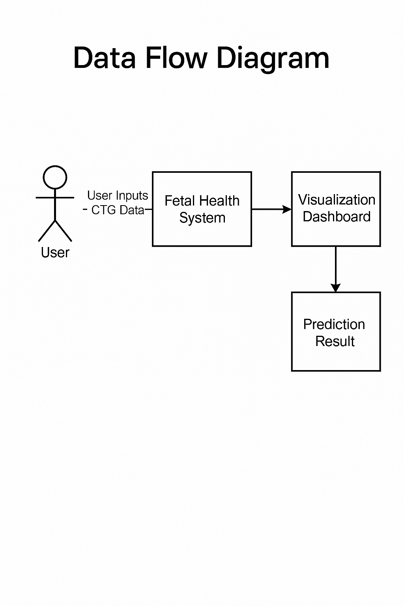

4.Use Case Diagram:
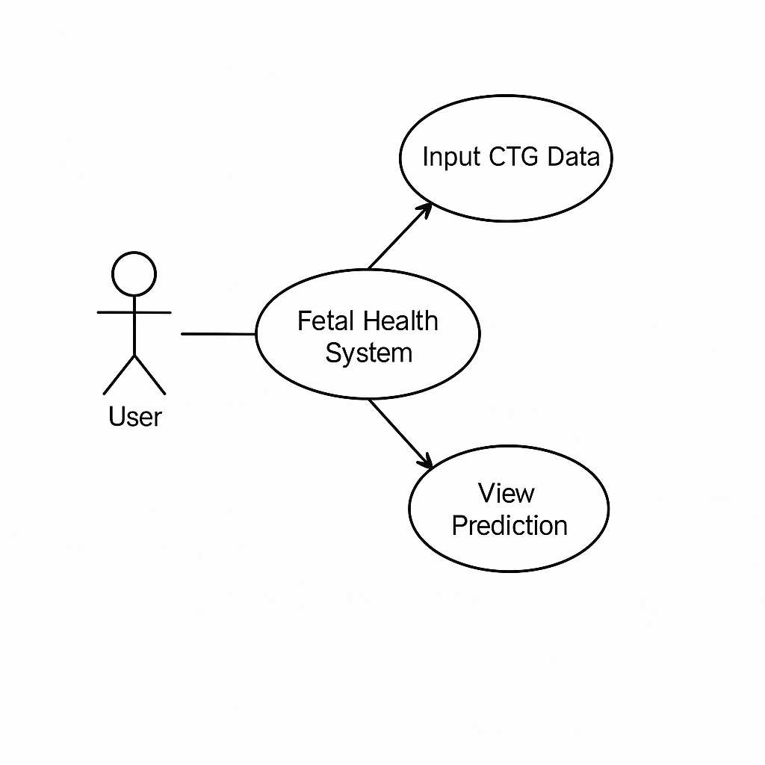

5. Software Requirements:

a) Operating System:
- Web-based or local system (compatible with Windows/Linux/Ubuntu)
- Optionally deployable on cloud (Heroku, AWS)

b) Hardware Requirements:
- Minimum 4GB RAM
- Dual-core processor or higher
- For training large models, GPU-enabled system recommended

c) Software Requirements:
- Programming Language: Python
- Libraries: Pandas, NumPy, Scikit-learn, Matplotlib, Flask (for web app)
- IDE: Jupyter Notebook / VS Code
- Database (Optional): SQLite or Firebase for saving user history
- Version Control: Git for source control and team collaboration

6. Sample Code:
import pandas as pd
from sklearn.model_selection import train_test_split
from sklearn.ensemble import RandomForestClassifier
from sklearn.metrics import classification_report, accuracy_score
import joblib

# 1. Load Dataset
url = "https://raw.githubusercontent.com/selva86/datasets/master/fetal_health.csv"
df = pd.read_csv(url)

print("Dataset loaded successfully.")
print("Shape:", df.shape)
print("Columns:", df.columns.tolist())

# 2. Feature Selection
X = df.drop("fetal_health", axis=1)
y = df["fetal_health"]
# 3. Train-Test Split
X_train, X_test, y_train, y_test = train_test_split(X, y, test_size=0.2, random_state=42)

# 4. Train Model
model = RandomForestClassifier(n_estimators=100, random_state=42)
model.fit(X_train, y_train)

# 5. Predict
y_pred = model.predict(X_test)

# 6. Results
print("\nClassification Report:")
print(classification_report(y_test, y_pred))
print("Accuracy Score:", accuracy_score(y_test, y_pred))

# 7. Save model (optional)
joblib.dump(model, "fetal_health_model.pkl")
print("Model saved as fetal_health_model.pkl")

7. Outputs:
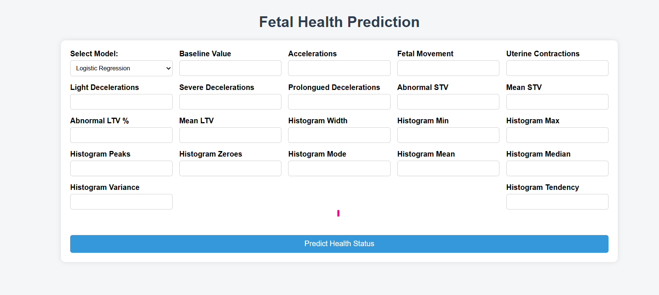
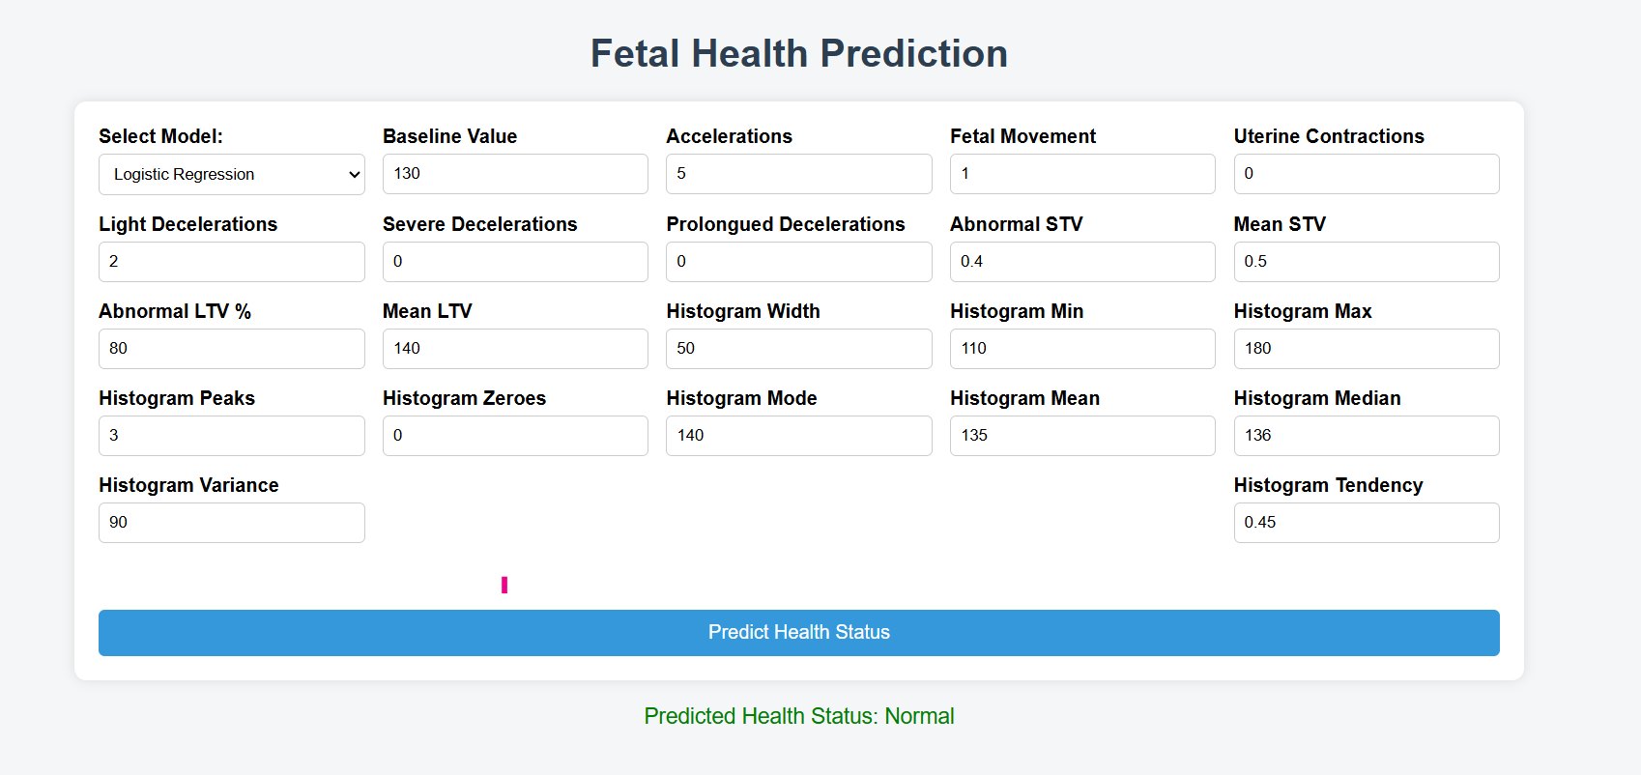

8. Conclusion:
The Fetal Health Monitoring and Prediction System marks a significant step forward in leveraging machine learning and clinical data for early diagnosis and enhanced prenatal care. By providing a data-driven approach to classifying fetal health into normal, suspect, or pathological categories, this system supports healthcare professionals in making timely and accurate decisions.
Its user-friendly interface, real-time prediction capabilities, and efficient processing of cardiotocographic data ensure that the tool is both accessible and effective for medical use. The solution enhances diagnostic reliability, reduces dependency on manual interpretation, and contributes to better health outcomes for both mothers and infants.
By combining medical insights with advanced data analytics, this system paves the way for intelligent healthcare applications. It exemplifies the power of AI in transforming maternal healthcare and underscores the importance of innovation in medical diagnostics.

9. Future Enhancement:
To continually enhance functionality and better support healthcare professionals, several improvements are proposed for future versions of the system:
- Deep Learning Integration: Implementing more complex models such as LSTM or CNN for higher prediction accuracy using time-series data.
- Mobile Application: Developing a mobile app version for real-time fetal monitoring and prediction in remote or rural areas.
- Real-time Data Integration: Enabling direct integration with medical devices (e.g., CTG machines) to collect and process data in real-time.
- Cloud-based Access: Deploying the system on cloud platforms to ensure data availability, scalability, and remote access for telehealth use cases.
- Patient History Dashboard: Adding a patient history panel to store and retrieve past records for comparative analysis and long-term tracking.
- Doctor-Patient Portal: Building secure multi-user support so both doctors and patients can log in and access relevant data and predictions.
- Multilingual Support: Localizing the application to support multiple languages for broader usability across diverse regions.
- Security Enhancements: Implementing advanced encryption, role-based access control, and secure data sharing to meet healthcare data regulations.
- Explainable AI: Integrating explainable ML tools to help clinicians understand why a certain prediction was made, increasing trust and transparency.
- Collaboration with Hospitals: Partnering with hospitals and research institutions to validate the system with real-world clinical data.

